Human computer interaction design

**Phase #3– designing alternatives for SUrveypro, an online survey system**

Table of Contents

Scenario 2

Storyboard 3

Design Alternatives With Low-fidelity prototypes and explanation 5

Prototypes 5

explanation 10

Reason for The Choice of the design 10

How To Use the Chosen design 11

Chosen Prototype Link (Proto.io): 12

User’s feedback on the prototype, scenario and storyboard 12

Things needed to be considered for future development 13

Bibliography 14

# **Scenario**

Mike and Emily are two college students who have become deeply involved in their own research projects and are struggling with the challenging task of gathering data through surveys. They get together frequently in the bustling college library, huddling over textbooks and laptops, to discuss academic obstacles and methods for succeeding in their studies.

One day, as Mike thoroughly looks for ways to improve the efficiency of his data collection, he comes across SurveyPro, an online survey system that claims to make the process of creating surveys and getting data much simpler. Excited by the potential time and effort savings, he makes the decision to dive right into this cutting-edge tool.

Similar research difficulties are being faced by Mike's close friend and research enthusiast Emily. During their routine study session, Mike cannot control his excitement and tells Emily about SurveyPro. Emily's interest is aroused by his explanation of its user-friendly interface, adjustable survey forms, and real-time response tracking.

Emily makes the decision to visit SurveyPro's website to learn more about its features since she is intrigued. As she explores the site, she finds a wide range of resources, such as an extensive collection of pre-designed survey templates, highly advanced data analysis tools, and an option to quickly share surveys with respondents. These elements, in Emily's opinion, have the potential to completely transform the way she conducts her study.

Emily makes the bold decision to use SurveyPro to build her first survey. She finds the procedure to be incredibly simple to follow and is pleased with the kind of customisation she can give to her surveys. She creates a professional-looking questionnaire that is specifically suited to her research objectives in just a few clicks.

Emily will use SurveyPro throughout the coming weeks to conduct surveys for her numerous research topics. As a result of the platform's seamless integration with her research processes, she is able to make well-informed choices quickly because of its real-time data collection and analysis tools.

On a bright campus day, Mike runs into Emily and is excited to find out about her accomplishments. As she describes how SurveyPro has changed her research approach, Emily is unable to hide her excitement. She emphasizes how it hasn't just saved her valuable time, but also improved the level of her data collection, producing more reliable research results. Mike is delighted to see Emily succeeding and taking advantage of the benefits of SurveyPro, and he feels honoured to have introduced her to this revolutionary technology. Together, they keep looking for new methods to use SurveyPro to achieve their academic goals because they are sure that it will be important for their success in the future.

# **Storyboard**

Scene 1: Mike and Emily are studying together in the college library while talking about their final exam preparations and research projects.

Scene 2: Mike talks about SurveyPro, and when Emily shows interest, Mike continues to explain its features and advantages.

Scene 3: Mike advises Emily to use SurveyPro to create and conduct surveys for her research projects in order to collect significant information. Emily says she'll try it out.

Scene 4: After returning home, Emily visits the SurveyPro website where she creates and tailors surveys according to her specific research requirements.

Scene 5: Over the next couple of days, Emily makes use of SurveyPro to rapidly conduct surveys and gather data for her projects.

Scene 6: One day, Emily meets Mike on campus. Emily expresses her gratitude to Mike for introducing her to SurveyPro and emphasizes how it has greatly helped in her research process and data collection tasks.

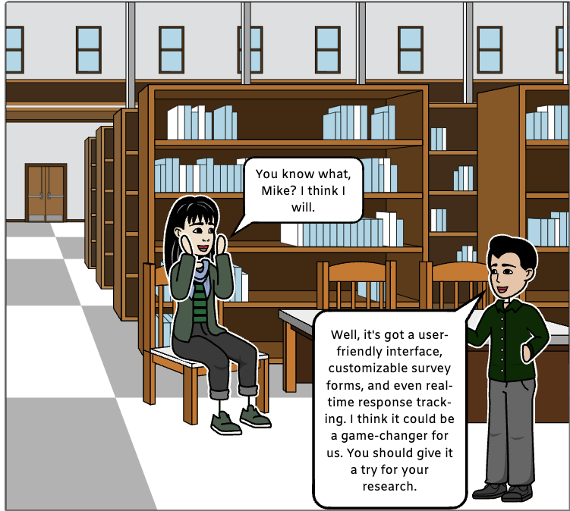

# **Design Alternatives With Low-fidelity prototypes and explanation**

# **Prototypes**

**Prototype #1**

**Prototype #2**

**Prototype #3**

# **explanation**

**Design Alternative 1:**

This layout has a clear, straightforward interface with lots of white space, easy-to-use navigation menus, and basic question structuring.

The primary goals of minimalist design are usability and simplicity. Respondents can easily browse through questions without interruptions, while survey developers can swiftly construct surveys. Making the survey-taking process simple and effective is the aim. By reducing visual clutter, this design makes it possible for visitors to concentrate on the survey's content rather than its intricate navigation.

**Design Alternative 2:**

In modern and visual design, aesthetics and user interaction are highly valued. The aesthetic attractiveness of SurveyPro is significantly altered in this design. The UI is sleek, contemporary, and easy to use. It has a simple design with eye-catching images, vivid colour schemes, and bold typography. The whole user experience is improved by SurveyPro's aesthetically arresting approach to survey-taking. The experience of doing surveys will be enhanced for users as they immerse themselves in a modern and captivating environment. With its cutting-edge and aesthetically pleasing platform, this design decision seeks to differentiate itself in the crowded field of online surveys.

**Design Alternative 3:**

A traditional, simple and user-friendly navigation mechanism is included into this design. This design, which mimics the survey's linear flow, makes sure that users can complete it with ease.

This design has a sidebar in addition to the navigation bar, which gives users an additional tool. Users can navigate to certain portions of the survey by using the sidebar, which offers an overview of its sections. This option can be very helpful for long surveys that have several sections or subjects. This alternative design achieves a balance between simplicity and functionality by fusing the sidebar with the traditional navigation bar. Users can take advantage of the efficiency and structure provided by the sidebar while still feeling in control and comfortable.

# **Reason for The Choice of the design**

Design Alternative 3, or Simple & Minimalistic Design, was chosen for SurveyPro due to its benefits of offering a streamlined and user-friendly interface. This design decision puts accessibility, efficiency, and clarity first, which is consistent with our objective of providing a user-friendly survey platform.

SurveyPro's basic design makes it easy for users to navigate quickly and efficiently, which lowers the learning curve and makes it usable by people with different degrees of technological expertise. This design promotes users to concentrate on survey questions by reducing distractions and emphasizing content, which eventually results in more deliberate and accurate responses.

We understand the need of incorporating some elements from other design alternatives in addition to the selected design to improve the user experience altogether. With this innovation, survey participants are guaranteed to feel assured and supported. Additionally, we may utilize Design Alternative 1 as a model to provide progress monitoring, which will encourage people to participate and keep them interested throughout the survey. Our goal is to produce a comprehensive and user-centric survey system that meets a wide range of user demands and preferences by fusing the greatest features from other alternatives with the simplicity of Design Alternative 3.

# **How To Use the Chosen design**

The experience with SurveyPro begins with the homepage, which features a simple, uncomplicated design. Its ease of usage is immediately apparent due to its simplicity. There are two main choices available to you: sign up or log in.

To take part in surveys if you're new to SurveyPro, use the "Sign Up" button. This stage guarantees an easy-to-use onboarding procedure, making it simple for anyone to become a member of the SurveyPro community.

After you sign up, the simple design approach is still reflected on our "About Us" page. You can click on “About Us” page to know about SurveyPro. This page offers information on the vision, core principles, and development team of SurveyPro. Users may easily comprehend the goals and guiding principles of the platform because to its simple appearance.

After that, you can click on privacy page to know about the privacy policies. SurveyPro is committed to protecting your data's privacy and security. The "Privacy" page explains the steps taken to protect your information in a clear and understandable manner. The platform's privacy promises are simply understood by users thanks to its basic design, which also stresses readability.

Then comes the dashboard which on click will open the dashboard page. The dashboard is where survey authors manage every aspect of their SurveyPro experience. Its simple, straightforward design makes it simple to handle your surveys and obtain important data. You can monitor the status of your survey and conduct distraction-free data analysis with clarity and efficiency.

You can click on Survey to take a survey. Taking surveys is the central component of your SurveyPro experience as a respondent. To minimize distractions, the survey interface presents one question at a time in accordance with the minimalist philosophy. The survey is easy to use, and respondents can complete the questions quickly.

At last, you can click on survey report to get the survey results. The creators get access to an easy-to-understand survey report presentation once the survey is finished. With this style, data interpretation is made simple and survey results may be analyzed effectively. The valuable material is still the major focus in this simple setting, giving survey authors clearly comprehensible and useful insights.

# **Chosen Prototype Link (Proto.io):**

LINK: <https://pr.to/88RICN/>

Alternative Way to Run: You can also run using the file submitted with this document. Open the SurveyPro-html folder. After that, open the src folder. Then, run the index.html file.

# **User’s feedback on the prototype, scenario and storyboard**

The feedback we received from our target users as well as from other student participants clarified the general efficacy of our selected Simple & Minimalistic Design. Users were generally in agreement on how appealing the simple, uncluttered UI was. They discovered that it greatly improved the survey-taking experience by making participation and navigation simple and intuitive. Notably, this design decision was praised for accommodating users with different degrees of technological expertise, which is consistent with SurveyPro's dedication to diversity.

We discovered a topic of interest that some students had mentioned in relation to future development: the incorporation of gamified components. Although gamification is desired, our current design favours simplicity, thus there may be room to find a middle ground between improved user engagement and simple usage. In later iterations, we intend to investigate adding gamified elements, keeping in mind the fundamentals of simplicity and adding a touch of interaction to improve the user experience.

Our primary target user was a clear supporter of the ease of use and simplicity that come with creating surveys. Her satisfying experience validated our design decisions. This user feedback encourages us to keep improving SurveyPro so that it continues to be a platform that is focused on the needs of its users while also validating the efficacy of our design.

# **Things needed to be considered for future development**

As we work to continuously enhance SurveyPro, we've given great thought to the insightful input that our users have given us. Examining gamification elements with the express goal of raising student engagement is an important area for future research. Although we prioritized clear usability with our Simple & Minimalistic Design, the indicated interest in gamified features allows us to add a touch of interactivity. The user experience will surely be improved by this tasteful combination of involvement and simplicity, making SurveyPro even more alluring and adaptable.

Data visualization is a crucial component of development as well. We are planning to improve our data visualization capabilities in order to enable more thorough examination. With the help of this tool, users will be able to comprehend the data acquired from their surveys on a deeper level and with greater comprehensiveness. Because we want SurveyPro to be a flexible tool for a range of applications, strong data visualization makes sure that our platform can handle a wide range of requirements, from business intelligence to academic study.

It becomes clear that customization is a key idea for our continued advancement. SurveyPro strives to offer a flexible platform that adjusts to individual tastes, whether it is used to create a customer feedback form, a market research questionnaire, or a student engagement survey. Furthermore, we have not wavered in our dedication to data security. Data security protocols will be strengthened in future development to guarantee optimal protection of user data and answers. Finally, there will soon be a significant investment made in user education. By providing clear and comprehensive materials, we hope to enable every user to easily take full advantage of our platform. Our future development efforts will continue to prioritize this dedication to help and advice, ensuring that SurveyPro is a comprehensive and user-friendly tool available to anyone.

# **Bibliography**

Figma. (n.d.). Figma. <https://www.figma.com/files/recents-and-sharing/recently-viewed?fuid=1290771096602899247>

(n.d.). Cacoo | Online diagramming tool for collaborative diagramming | Nulab. [https://cacoo.com/](https://cacoo.com/signin)

(n.d.). Google Forms: Sign-in. <https://forms.google.com/>

Preece, J., Sharp, H., & Rogers, Y. (2015). Interaction design: Beyond human-computer interaction. John Wiley & Sons.

(2022, July 27). Qualtrics. <https://www.qualtrics.com/>

(n.d.). Stack Overflow. <https://stackoverflow.com/>

(n.d.). SurveyMonkey. <https://www.surveymonkey.com/>

(n.d.). Proto.io. <https://share.proto.io/88RICN/>

(n.d.). Typeform. <https://www.typeform.com/>

Prototypes, C. (n.d.). Storyboard creator | Comic strip maker | Storyboard maker. Storyboard That. [https://www.storyboardthat.com/storyboard-creator#](https://www.storyboardthat.com/storyboard-creator)